Module B.1 – Simon Pseudo Code

Ramin

**Level 1)**

1. When you turn the Simon game on, it gives you more than one option. Clicking the green button, it will allow the co-op mode, clicking the red button it allows the single player mode. The Yellow button will show you the highest score. For any colour you select it will start the game and you would have to repeat the colors it displays.
2. If the red button is pressed, than the single player mode starts. If the green button is pressed than the co-op mode starts. If the yellow button is pressed than pressed

|  |  |  |
| --- | --- | --- |
| **Object** | **Action** | **Result** |
| Red Button | Push | If the game didn’t start, start it in single player, check if that was the correct color displayed in the pattern. |
| Green button | Push | If the game didn’t start, start it in the co-op mode, check if that was the correct color displayed in the pattern |
| Yellow button | push | If the system didn’t start, turn the system on and check if it states the high score, Check if it displayed the correct colors |
| Blue Button | push | If the game is not turned on than, first turn the game on if the game is in process. Check if the correct color is displayed in the pattern |

|  |  |  |
| --- | --- | --- |
| **Object** | **Action** | **Meaning** |
| Red Light | Play tone | This will display a sound depending on the colors shown in the pattern |
| Blue Button | Play tone | This will display a sound depending on the colors shown in the pattern |
| Green Button | Play tone | This will display a sound depending on the colors shown in the pattern |
| Yellow button | Play tone | This will display a sound depending on the colors shown in the pattern |

**Level 2)**

1. First you will select the game mode, either single player, or co-op mode. After that it will send back a pattern of colors that you would have to repeat after its done showing the pattern. If you fail the pattern than you would have to restart the game.
2. If you select the single player mode or the co-op mode, than the game will start. If the games start, than you would have to repeat the colors the light hits after the pattern is done.
3. If the red button is clicked than move onto the next color. If the green button is clicked than move onto the next color. If the blue button is clicked than click the new pattern. If the color you picked is wrong, than the game will end.
4. If the correct color is pressed than move onto the next color. If the wrong color is pressed than the game will end.

|  |  |  |
| --- | --- | --- |
| **Object** | **Action** | **Result** |
| Red Button | Push | If the game didn’t start, start the game in single player and ensure you clicked the correct button. |
| Green Button | push | If the game didn’t start, start the game in co-op mode and ensure you clicked the correct button |
| Blue Button | Push | If the system is not turned on than turn it on and ensure the correct button is clicked |
| Yellow Button | Push | If he system didn’t turn on turn it on, show the high score and ensure the correct button is clicked |

6)

|  |  |  |
| --- | --- | --- |
| **Object** | **Action** | **Meaning** |
| Red button | Play tone | This will play a sound depending on the colors shown in the patterns |
| Blue button | Play tone | This will play a sound depending on the colors shown in the patterns |
| Yellow button | Play tone | This will play a sound depending on the colors shown in the patterns |
| Green button | Play tone | This will play a sound depending on the colors shown in the patterns |
| The LED’s | Lights up | The LED’s are under the colors because, when it displays the pattern the colors light up, so when you repeat the colors you know is the answer for the pattern |
| The sounds | Plays sounds | There are different sounds in the game. There is either a good sound or a bad sound. The good sounds occurs when you get the pattern correct, and the bad sound occurs when toy get the pattern wrong. It also makes a sound when the game starts. |

**Level 3)**

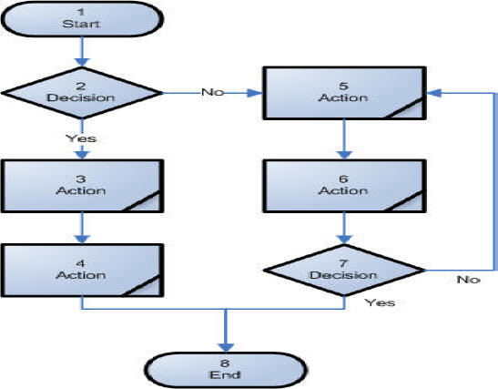

2)

Flowchart usually uses a square or a circle flow chart to represent different types of actions or steps in a process. Line and arrows show the sequence of the steps, and the relationships among them. These are known as flowchart symbols. The type of diagram dictates the flowchart symbols that are used.